**Smart Triage system for Patient Assignment   
after Disaster**

**Anjali Dongre, Ritika Rajput, Neelam Netke, Varsha Pardeshi**

Department of Computer Engineering, SSBT Collage of Engineering and Technology Jalgaon, Maharshtra, India .

Abstract - The design and implementation of a system to automate patient handling and searching nearby hospitals in mass disasters involving a large number of injured victims over a wireless network. This is the reason why this

paper intends to apply the mentioned technology to the triage process based on real data of the Emergency Department . This research proposes a model to classify the care priority of patients in emergency using machine learning techniques based on medical criteria and predefined variables as well as quick assignment of patients to nearby hospitals. Patients are prioritized for medical care through a triage process. Manual systems allow for inconsistency and error. It proposes a novel system to automate accident and emergency center triage and uses this triage score along with an artificial intelligence estimate of patient-doctor time to optimize the queue order. The optimal queue order is found using a novel procedure . It is expected that chaotic mass-disaster situations can be more suitably controlled and stabilized by using the techniques from this project, thus saving more lives.

Keywords - Mass disaster, Location aware, triage, disaster site

I. INTRODUCTION

Machine Learning is a technique that allows computers to learn through programs that generalize behaviors from information or a set of patterns of data. Machine learning algorithms have existed for two decades, but recently, their application has become popular because of growth of power in computing and data storage. It is also important to indicate that there are several models for resolutions of problems in machine learning. In recent years, machine learning methods have been widely used in prediction, especially in medical decision making.

Triage is derived from the French term Trier which means "to select or choose / to choose or to classify", and it refers to a system that quickly evaluates the severity of each patient and indicates the best treatment depending on his/her condition. Usually triage is used in emergency department to screen patients before proceeding to any treatment. Triage is an important stage in the patient journey to ensure the best use of resources, patient satisfaction, and safety. Triage systems have also been found to be reliable in predicting admission to hospital, but are most reliable at extreme points of the scale, and less reliable for the majority of patients who fall in the mid points.

The design and implementation of a triage system to automate patient handling and searching nearby hospitals in mass disasters involving a large number of injured victims over a wireless network .System includes location-aware features at the disaster site, as well as proposes a model to classify the care priority of patients in emergency using machine learning techniques based on medical criteria and predefined variables as well as quick assignment of patients to nearby hospitals. In any mass-disaster situation such as a building collapse, earthquake, or flash floods, it is expected that many agencies would rush to aid the victims. Given the possible large number of victims, the situation can quickly become unmanageable, and chaos can reduce the chances to save lives. In addition, chaos can limit the ability of area hospitals to identify and treat the most critically injured victims in a timely manner. The triage service is a crucial part and only way to better distribute the resources of the hospitals process of categorizing patients to appropriate care level that medical needs. The decision process must take into consideration the seriousness of the patient’s medical complaint.

II. RELATED WORKS

Using a range of clinical and demographic data relating to elderly patients, La Mantiana et al. [9] used logistic regression to predict admissions to hospital, and ED re-attendance. They predicted admissions with moderate accuracy, but were unable to predict ED re-attendance accurately. The most important factors predicting admission were age, Emergency Severity Index (ESI) triage score, heart rate, diastolic blood pressure, and chief complaint [9] (pg. 255). Baumann and Strout [20] also find an association between the ESI and admission of patients aged over 65. Boyle et al. used historical data to develop forecast models of ED presentations and admissions. Model performance was evaluated using the mean absolute percentage error (MAPE), with the best attendance model achieving a MAPE of around 7%, and the best admission model achieving a MAPE of around 2% for monthly admissions. The use of historical data by itself to predict future events has the advantage of allowing forecasts further into the future, but has the disadvantage of not incorporating data captured at arrival and through triage, which may improve the accuracy of short term forecasting of admissions.

Sun et al. [8] developed a logistic regression model using two years of routinely collected administrative data to predict the probability of admission at the point of triage. Risk of admission was related to age, ethnicity, arrival mode, patient acuity score, existing chronic conditions, and prior ED attendances or admission in the past three months. Although their data showed the admission of more females than males, sex was not significant in the final model. Similarly, Cameron et al. [11] developed a logistic regression model to predict the probability of admissions at triage, using two years of routine administration data collected from hospitals in Glasgow. The most important predictors in their model included 'triage category, age, National Early Warning Score, arrival by ambulance, referral source, and admission within the last year' (pg. 1), with an area under the curve of the receiver operating characteristic (AUC-ROC) of 0.877. Other variables including weekday, out of hour’s attendances, and female gender, were significant but did not have high enough odds ratios to be included in the final models.

Similarly, Peck et al. [12] developed three models to predict ED admissions using logistic regression models, naive Bayes, and expert opinion. All three techniques were useful in predicting ED admissions. Variables in the model included age, arrival mode, emergency severity index, designation, primary complaint, and ED provider. Their logistic regression model was the most accurate in predicting ED admissions, with an AUC-ROC of 0.887. Perhaps surprisingly, this model performed better than triage nurse’s opinion regarding likely admission. Using simulation models, Peck et al. [13] have shown that the use of the predictive models to priorities discharge or treatment of patients can reduce the amount of time the patient spends in the ED department.

III. METHODOLOGY

This work focuses the enhancement of the triage process of the emergency room using machine learning technique based on several independent variables i.g. vital signs, pain scales and Glasgow coma scale, and dependent variables i.e. classification given to the patient. These process will deliver a level of priority based on the Canadian Triage and Acuity Scale (CTAS), which determines 5 levels of attention (see Table 1).

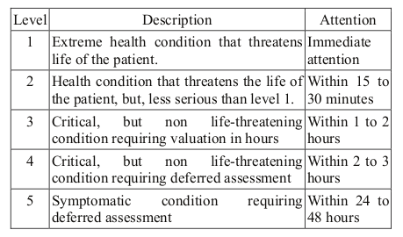

The enhanced system identifies the nearest hospitals to a mass-disaster location . To the best of our knowledge, none of the existing patient-data communication schemes handle the patient assignment problem. Pre-assigning patients to most suitable hospitals can reduce the chaos and confusion in a triage room dealing with a mass disaster. A web portal is designed to let the authorized users obtain vital statistics about the overall disaster management scenario.

The client uses the GPS system for self-location. Based on its position, it searches for nearby hospitals using public data and connects to the server-side software of triage system. The position of the client is then transferred to the server to determine the disaster location. The client software attempts to establish connection with the server and finds nearby hospitals within 50 km. The paramedics use color-coded paper triage tags. The six color codes include white (non urgent), green (less urgent), yellow (urgent), red (emergent), blue (extremely urgent), and black (dead). Based on the available information, the server checks crates a queue and assigns a triage level to a patient.

Next, the server notifies the client about the assignments for all the patients triage levels .A system is implemented at the client (disaster) side that finds the nearest hospitals and automates the process of patient data flow to the hospitals. In addition, algorithm at the server (hospital) side that assigns patients triage using naive bayes classification algorithm. The GPS location of both i.e. disaster site and hospital will be calculated .Assigned hospital will be informed to send ambulance at the disaster site.

IV. IMPLEMENTATION

System is implemented using the following technology stack :-

Flask (Python Framework)

Scikit-Learn (Machine learning library)

Additional libraries like pandas and numpy.

**Scikit-learn** is a [free software](https://en.wikipedia.org/wiki/Free_software) [machine learning](https://en.wikipedia.org/wiki/Machine_learning) [library](https://en.wikipedia.org/wiki/Library_(computing)) for the [Python](https://en.wikipedia.org/wiki/Python_(programming_language)) programming language. It features various [classification](https://en.wikipedia.org/wiki/Statistical_classification), [regression](https://en.wikipedia.org/wiki/Regression_analysis) and [clustering](https://en.wikipedia.org/wiki/Cluster_analysis) algorithms including [support vector machines](https://en.wikipedia.org/wiki/Support_vector_machine),[random forests](https://en.wikipedia.org/wiki/Random_forests), [gradient boosting](https://en.wikipedia.org/wiki/Gradient_boosting), [*k*-means](https://en.wikipedia.org/wiki/K-means_clustering) and [DBSCAN](https://en.wikipedia.org/wiki/DBSCAN), and is designed to interoperate with the Python numerical and scientific libraries [NumPy](https://en.wikipedia.org/wiki/NumPy) and [SciPy](https://en.wikipedia.org/wiki/SciPy). We are using Naive Bayes Algorithm it is a statistical classification technique based on Bayes Theorem. It is one of the simplest supervised learning algorithms. Naive Bayes classifier is the fast, accurate and reliable algorithm. Naive Bayes classifiers have high accuracy and speed on large datasets.

Naive Bayes classifier assumes that the effect of a particular feature in a class is independent of other features.

## **Classification Work flow**

Whenever we perform classification, the first step is to understand the problem and identify potential features and label. Features are those characteristics or attributes which affect the results of the label. For example, in our system in case of assigning triage level, we have to specify patient-data Age**,** Gender**,** Pulse**,** B/P**,** Temperature**,**Alert**,** Voice Responsive**,** Pain Responsive**,**Unconscious**,** Airway Breathing**,** Oxysat **and** Triage_level. These characteristics are known as features which help the model classify Triage levels.

The classification has two phases, a learning phase, and the evaluation phase. In the learning phase, classifier trains its model on a given dataset and in the evaluation phase, it tests the classifier performance. Performance is evaluated onthe basis of various parameters such as accuracy, error, precision, and recall.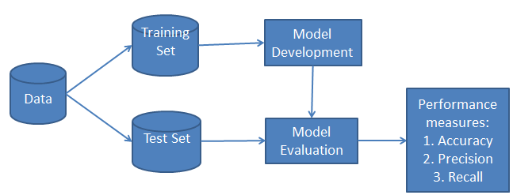

This assumption simplifies computation, and that's why it is considered as naive. This assumption is called class conditional independence.

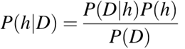

* P(h): the probability of hypothesis h being true (regardless of the data). This is known as the prior probability of h.
* P(D): the probability of the data (regardless of the hypothesis). This is known as the prior probability.
* P(h|D): the probability of hypothesis h given the data D. This is known as posterior probability.
* P(D|h): the probability of data d given that the hypothesis h was true. This is known as posterior probability.

**Naive Bayes classifier working:**

* Step 1: Calculate the prior probability for given class labels
* Step 2: Find Likelihood probability with each attribute for each class
* Step 3: Put these value in Bayes Formula and calculate posterior probability.
* Step 4: See which class has a higher probability, given the input belongs to the higher probability class.

**Building** **Naive Bayes classifier Model:**

Step 1: Load dataset from csv file and convert it into dataframe using pandas.

* Step 2: we need to convert these string labels into numbers .This is known as label encoding. Scikit-learn provides LabelEncoder library for encoding labels with a value between 0 and one less than the number of discrete classes.
* Step 3: Clean and standardise the data.
* Step 4: split data into training and testing data.

Step 5: Create naive bayes classifier and Fit the dataset on classifier

to Perform prediction.

* Step 6: store model for predicting triage using pickles.

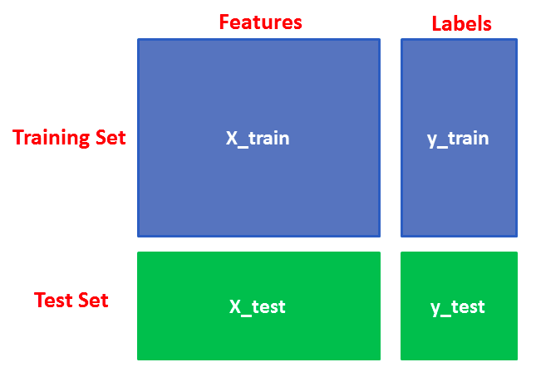

**Server using flask and hospital searching**

* Step 1: Input will be received from client side in JSON format.
* Step 2: Load stored model using pickles at server side.
* Step 3: Return calculated triage to client side in JSON format.
* Step 4: Foursquare places api is used for finding nearby hospitals according to our provided parameters and endpoints.
* Step 5: List of nearby hospitals and triage levels will be displayed at client side.

CONCLUSION

The system decribes automate patient handling and searching nearby hospitals in mass disasters involving a large number of injured victims over a wireless network. This paper intends to apply the mentioned technology to the triage process based on real data of the Emergency Department . This research has proposed a naive bayes model to classify the care priority of patients in emergency using machine learning techniques based on medical criteria and predefined variables as well as quick assignment of patients to nearby hospitals. Patients are prioritized for medical care through a triage process. Manual systems allow for inconsistency and error and they are slow and based on persons knowledge and experience. It proposes a novel system to automate accident and emergency center triage and optimal queue order is found using a novel procedure. It is expected that chaotic mass-disaster situations can be more suitably controlled and stabilized by using the techniques from this project, thus saving more lives.

**REFERENCES**

[1]R. Olson, J.A. Zubairi, A. Biliciler, A software framework for patient data handling in emergencies and disasters, in: Int. Conf. Collab. Technol. Syst., CTS, 2014, pp. 553–557.

[2] M. Muaafa, A.L. Concho, J. Ramirez-Marquez, Emergency resource allocation for disaster response: an evolutionary approach, in: Probab. Saf. Assess. Manag. Conf., PSAM12, 2014.

[3] Yunfei, H., and Ting, L., 2014, "Performance comparison of four triage–based patient flow interventions in the emergency department," International Journal of Collaborative Enterprise, 4(2), pp. 115-135.

[4] D. Malan, T. Fulford-Jones, M. Welsh, S. Moulton, Codeblue: an ad

hoc sensor network infrastructure for emergency medical care, in: Int.

Workshop Wearable Implant. Body Sens. Netw., 2004.

[5] San Pedro, J., Burstein, F., Cao, P., Churilov, L., Zaslavsky, A.

&Wassertheil, J., Mobile Decision Support for Triage in Emergency

Departments. Decision Support in an Uncertain and Complex World:

The IFIP TC8/WG8.3 Organized in Italy, 2004.

[6] Abad-Grau, M. M., Ierache, J., Cervino, C. & Sebastiani, P., Evolution

and Challenges in the Design of Computational Systems for Triage

Assistance. *Journal of BiomedicalInformatics* 41(3): 432-441. 2008.

[7] Jeffrey Leegon, BS, Ian Jones, MD, Kevin Lanaghan, BS, and Dominik Aronsky, MD, PhD, “Predicting Hospital Admission in a Pediatric Emergency Department using an Artificial Neural Network”

[8] Y. Sun, B.H. Heng, S.Y. Tay, E. Seow, Predicting hospital admissions at emergency department triage using routine administrative data, Acad. Emerg. Med. 18 (2011) 844–850. doi:10.1111/j.1553-2712.2011.01125.x.

[9] M.A. LaMantia, T.F. Platts-Mills, K. Biese, C. Khandelwal, C. Forbach, C.B. Cairns, J. Busby-Whitehead, J.S. Kizer, Predicting hospital admission and returns to the emergency department for elderly patients, Acad. Emerg. Med. 17 (2010) 252–259. doi:10.1111/j.1553-2712.2009.00675.x.

[10] G.M. Marres, L. Taal, M. Bemelman, J. Bouman, L.P. Leenen, Online

victim tracking and tracing system (ViTTS) for major incident casualties,

Prehosp. Disaster Med. 28 (2013) 445–453.

[11] A. Cameron, K. Rodgers, A. Ireland, R. Jamdar, G.A. McKay, A simple tool to predict admission at the time of triage., Emerg. Med. J. 32 (2013) 174–9. doi:10.1136/emermed-2013-203200

[12] N. Esfandiari, M.R. Babavalian, A.M.E. Moghadam, V.K. Tabar, Knowledge discovery in medicine: Current issue and future trend, Expert Syst. Appl. 41 (2014) 4434–4463. doi:10.1016/j.eswa.2014.01.011.

[13] H.C. Koh, G. Tan, Data mining applications in healthcare, J. Healthc. Inf. Manag. 19 (2011) 65.